**Experiment: 5**

Write a shell script and C Program to perform the following string operations:

1. To Extract a substring from a given string

* 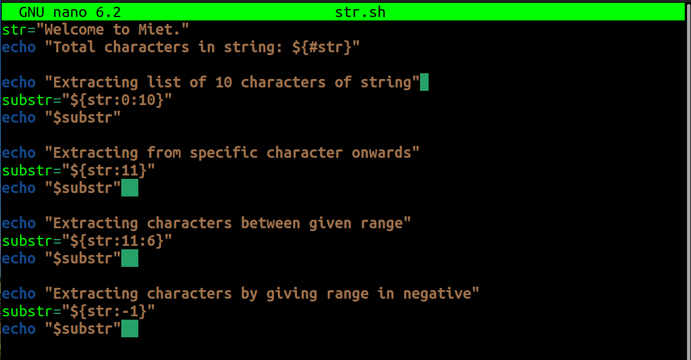Shell Script
* 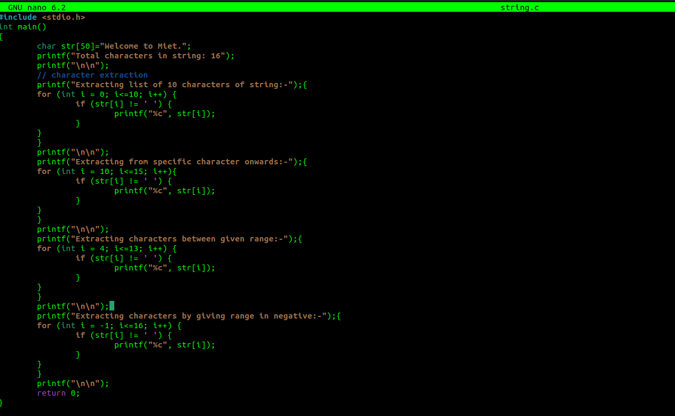C Program
* 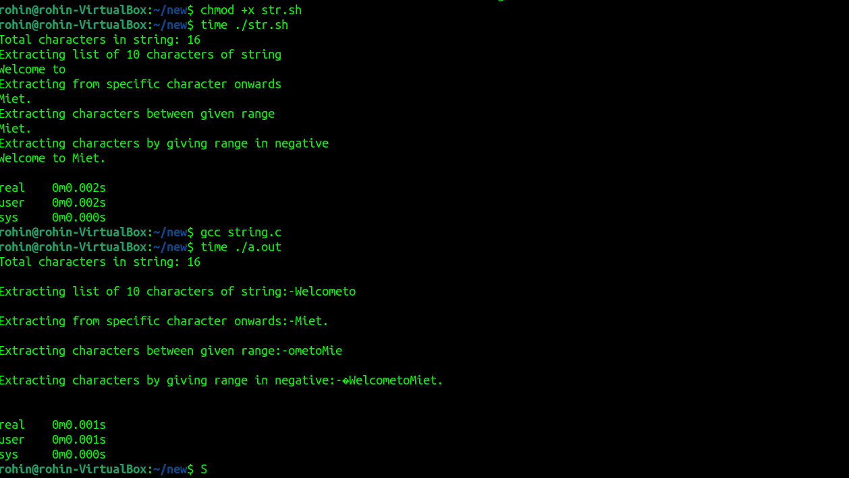Output using time command for both C program and shell script.

1. To find the length of a given string

* 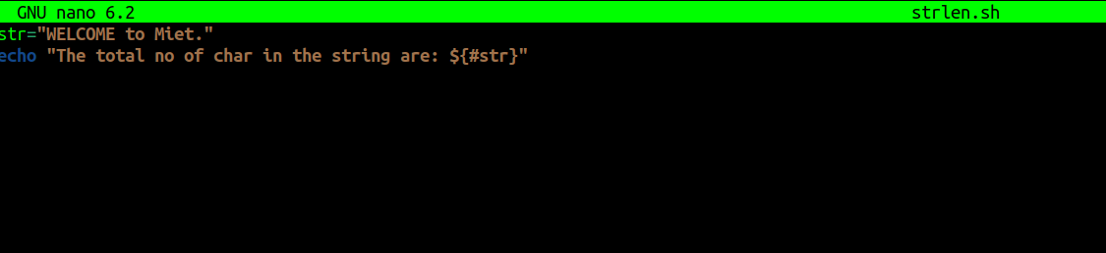Shell Script
* 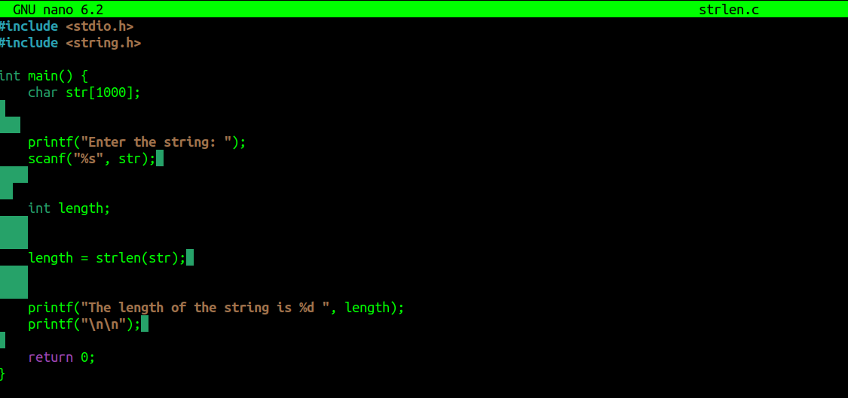C Program
* Output using time command for both c program and shell script.

